# Задание 1

**Скрипт:**

WITH BrandSales AS (

   SELECT

      b.BrandID,

      b.Name AS Brand,

      SUM(od.Quantity * od.Price) AS TotalSales

   FROM

      Orders o

   LEFT JOIN

      OrderDetails od ON o.OrderID = od.OrderID

   LEFT JOIN

      Products p ON od.ProductID = p.ProductID

   LEFT JOIN

      Brands b ON p.BrandID = b.BrandID

   WHERE

      o.OrderDate BETWEEN '2020-01-01' AND '2020-03-31'

   GROUP BY

      b.BrandID, b.Name

),

TotalSalesSum AS (

   SELECT

      SUM(TotalSales) AS TotalSalesAmount

   FROM

      BrandSales

)

SELECT

  bs.BrandID,

  bs.Brand,

  bs.TotalSales AS BrandTotalSales,

  t.TotalSalesAmount AS TotalSalesAmount,

  ROUND((bs.TotalSales / t.TotalSalesAmount) * 100, 1) AS SalesPercentage

FROM

  BrandSales bs

CROSS JOIN

  TotalSalesSum t

ORDER BY

  SalesPercentage DESC;

​

**Результат выполнения:**



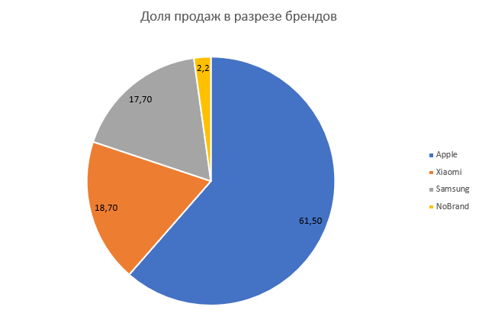

# Задание 2

Скрипт:

WITH MobileSales AS (

   SELECT

      b.BrandID,

      b.Name AS Brand,

      SUM(od.Quantity) AS TotalUnitsSold

   FROM

      Orders o

   LEFT JOIN

      OrderDetails od ON o.OrderID = od.OrderID

   LEFT JOIN

      Products p ON od.ProductID = p.ProductID

   LEFT JOIN

      Brands b ON p.BrandID = b.BrandID

   LEFT JOIN

      ProductCategory pc ON p.ProductCategoryID = pc.ProductCategoryID

   WHERE

      o.OrderDate BETWEEN '2020-01-01' AND '2020-03-31'

   GROUP BY

      b.BrandID, b.Name

),

TotalUnits AS (

   SELECT

      SUM(TotalUnitsSold) AS TotalUnitsSoldOverall

   FROM

      MobileSales

)

SELECT

  ms.BrandID,

  ms.Brand,

  ms.TotalUnitsSold AS BrandTotalUnitsSold,

  tu.TotalUnitsSoldOverall AS TotalUnitsSoldOverall,

  ROUND((ms.TotalUnitsSold * 100.0 / tu.TotalUnitsSoldOverall), 1) AS SalesPercentage

FROM

  MobileSales ms

CROSS JOIN

  TotalUnits tu

ORDER BY

  SalesPercentage DESC;

​

**Результат выполнения:**

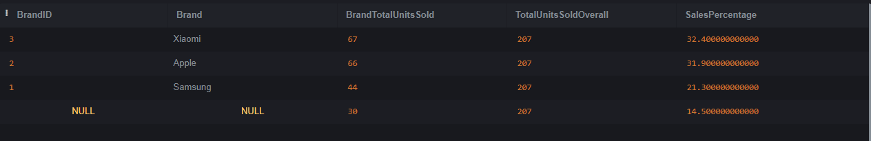

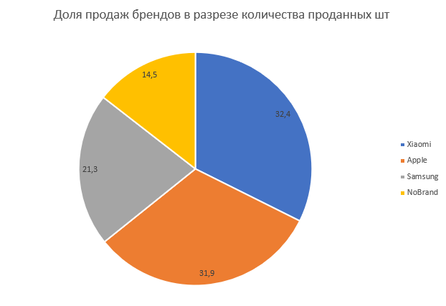

Бренды продают практически одинаковое количество единиц товара, но продукция Apple примерно в 2 раза дороже конкурентов.

# Задание 3

**Скрипт:**

SELECT TOP(10)

  c.LastName + ' ' + c.FirstName AS CustomerName,

  SUM(o.Total) AS TotalPurchaseAmount

FROM

  Orders o

LEFT JOIN

  Customers c ON o.CustomerID = c.CustomerID

WHERE

  o.OrderDate BETWEEN '2020-01-01' AND '2020-12-31'

GROUP BY

  c.LastName, c.FirstName

ORDER BY

  TotalPurchaseAmount DESC;

​

**Результат выполнения:**

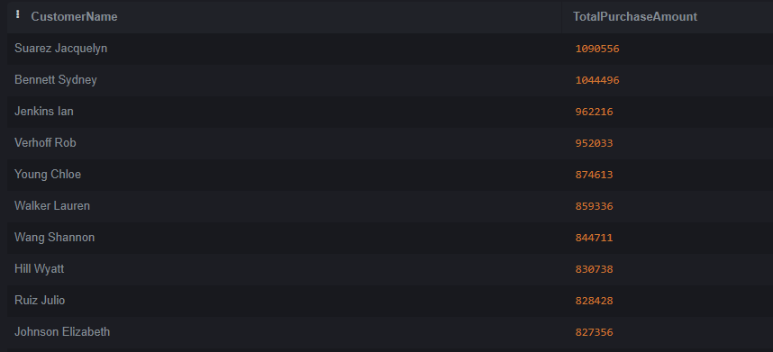

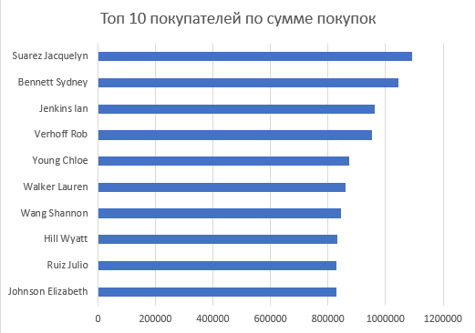

# Задание 4

**Скрипт:**

SELECT TOP(10)

  c.LastName + ' ' + c.FirstName AS CustomerName,

   COUNT(o.OrderID) AS OrdersCount

FROM

  Orders o

LEFT JOIN

  Customers c ON o.CustomerID = c.CustomerID

WHERE

  o.OrderDate BETWEEN '2020-01-01' AND '2020-12-31'

GROUP BY

  c.LastName, c.FirstName

ORDER BY

  OrdersCount DESC;

​

**Результат выполнения:**

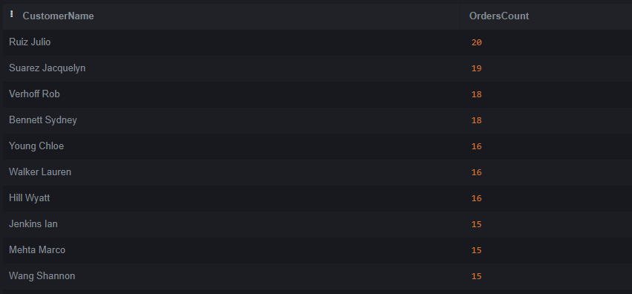

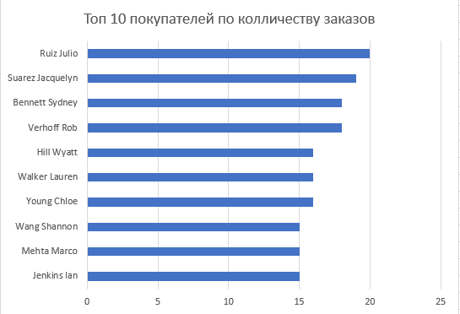

# Задание 5

**Скрипт:**

WITH MonthlySales AS (

   SELECT

       YEAR(o.OrderDate) AS Year,

      MONTH(o.OrderDate) AS Month,

       COUNT(o.OrderID) AS OrderCount,

      SUM(o.Total) AS TotalSales

   FROM

      Orders o

   WHERE

      o.OrderDate BETWEEN '2019-12-01' AND '2020-12-31'

   GROUP BY

       YEAR(o.OrderDate), MONTH(o.OrderDate)

)

SELECT

   Year,

  Month,

  OrderCount,

  TotalSales,

  TotalSales - LAG(TotalSales) OVER (ORDER BY Year, Month) AS SalesAbsoluteChange,

  OrderCount - LAG(OrderCount) OVER (ORDER BY Year, Month) AS OrderCountAbsoluteChange,

  CASE

      WHEN LAG(TotalSales) OVER (ORDER BY Year, Month) IS NULL THEN NULL

      ELSE ROUND((TotalSales - LAG(TotalSales) OVER (ORDER BY Year, Month)) * 100.0 / LAG(TotalSales) OVER (ORDER BY Year, Month), 2)

  END AS SalesRelativeChangePercent,

  CASE

      WHEN LAG(OrderCount) OVER (ORDER BY Year, Month) IS NULL THEN NULL

      ELSE ROUND((OrderCount - LAG(OrderCount) OVER (ORDER BY Year, Month)) * 100.0 / LAG(OrderCount) OVER (ORDER BY Year, Month), 2)

  END AS OrderCountRelativeChangePercent

FROM

  MonthlySales

ORDER BY

   Year, Month

OFFSET 1 ROWS;

​

**Результат выполнения:**

